SpaceAndro

음식 추천 프로그램

For<음식 추천해주는 어플리케이션>

Version <0.2.2>

2024.05.30

제출자 : 송원석

팀장 : 송원석

팀원 : 문승신

팀원 : 김지민

팀원 : 박상원

SpaceAndro는 송원석 문승신 김지민 박상원이 참여한 프로젝트입니다

최초 사용자의 정보를 입력 받아 그정보를 바탕으로 날씨 날짜등의 상황을 고려하여 음식을 추천하는 어플리케이션을 만드는 프로젝트입니다.

개정 이력

|  |  |  |  |
| --- | --- | --- | --- |
| **Date** | **Version** | **Description** | **Author** |
| <2024/03/26> | 0.1.1 | SpaceAndro문서를 생성함 | 송원석 |
| <2024/03/26> | 0.1.2 | SpaceAndro문서를 수정함 | 문승신 |
| <2024/04/16> | 0.1.3 | 프로젝트 계획서 작성 | 문승신 |
| <2024/04/29> | 0.1.4 | AI 모델 샘플 파일 작성 | 문승신 |
| <2024/04/30> | 0.1.5 | 전체 문서 수정 | 송원석 |
| <2024/05/07> | 0.1.6 | ERD 그림 추가, 표지 버전 수정 | 김지민 |
| <2024/05/07> | 0.1.7 | ERD 수정 | 김지민 |
| <2024/05/30> | 0.1.8 | 메인홈페이지 코드추가 및 이미지 추가 | 송원석 |
| <2024/05/30> | 0.1.9 | 화면 설계 이미지 추가 | 박상원 |
| <2024/05/30> | 0.2.0 | 로그인,회원가입,설문조사 코드 추가 | 박상원 |
| <2024/05/30> | 0.2.1 | 로그인,회원가입,설문조사 이미지 추가 | 박상원 |
| <2024/05/30> | 0.2.2 | 일정 추가(차트) | 송원석 |
|  |  |  |  |
|  |  |  |  |
|  |  |  |  |
|  |  |  |  |
|  |  |  |  |
|  |  |  |  |
|  |  |  |  |
|  |  |  |  |

목차

# 서론

* 최초 사용자의 정보를 입력받아 그정보를 바탕으로 날씨 날짜를 고려하여 음식을 추천해주는 어플리케이션을 만드는 프로젝트입니다.

## 개요

* 현대인의 바쁜 일상속에서 음식을 빠르게 선택하는것에 어려움이 있을수있습니다 이러한 문제를 해결해줄수 있는 어플리케이션을 만들어보고싶다고 생각해 시작하게 되었습니다.

## 목표

* 사용자 친화적인 인터페이스를 통해 날씨와 날짜를 고려하여 음식 추천서비스를 제공하는것입니다
* 항상 같은 날씨에 똑같은음식을 추천해주는 것에 대해 주의하여야합니다.

## 기대효과

* 음식 선택시간 단축 ,내가 언제 무슨 음식을 먹었는지 음식 캘린더 작성

# 본론

## 도구

* 파이썬,자바,DB

## 업무분장

* 데이터베이스
* 메인홈페이지,로그인폼,회원가입폼,회원탈퇴폼,캘린더폼(자바)
* AI모델(파이썬)

## 일정

## 화면설계

* *하단 그림 참조*

## UI

* 사용자 친화 디자인, 파스텔톤의 부드러운 색배열

## UX

* 기능적 요구사항 : 사용자 위치 기반 날씨 정보 획득, 날씨 및 기온에 따른 음식추천, 과거 선택 데이터 기반 추천 개선

## ERD

## 메인홈페이지(송원석)

* 소스코드
* <!DOCTYPE html>
* <html xmlns="http://www.thymeleaf.org">
* <html lang="ko">
* <head>
* <meta charset="UTF-8">
* <meta name="viewport" content="width=device-width, initial-scale=1.0">
* <title>Space - 음식 추천</title>
* <style>
* @import url('https://fonts.googleapis.com/css2?family=Dancing+Script:wght@700&display=swap');
* body {
* font-family: Arial, sans-serif;
* margin: 0;
* padding: 0;
* display: flex;
* flex-direction: column;
* min-height: 100vh;
* }
* header, footer {
* background-color: #333;
* color: white;
* padding: 1em;
* display: flex;
* justify-content: space-between;
* align-items: center;
* }
* header {
* position: relative;
* }
* header .title {
* position: absolute;
* left: 50%;
* transform: translateX(-50%);
* font-size: 2.5em;
* font-family: 'Dancing Script', cursive;
* background: linear-gradient(90deg, rgba(255, 255, 255, 0.5) 0%, rgba(255, 255, 255, 0.2) 100%);
* -webkit-background-clip: text;
* color: transparent;
* background-clip: text;
* }
* header .date {
* font-size: 1em;
* background: linear-gradient(90deg, rgba(255, 255, 255, 0.5) 0%, rgba(255, 255, 255, 0.2) 100%);
* padding: 0.2em 0.5em;
* border-radius: 10px;
* }
* footer {
* position: fixed;
* bottom: 0;
* width: 100%;
* justify-content: center;
* }
* .menu-bar {
* display: flex;
* justify-content: center;
* gap: 20px;
* }
* .menu-bar button {
* padding: 10px 20px;
* border: none;
* background-color: #888;
* color: white;
* cursor: pointer;
* border-radius: 25px;
* box-shadow: 0 4px 8px rgba(0, 0, 0, 0.2);
* transition: background-color 0.3s, box-shadow 0.3s, transform 0.3s;
* }
* .menu-bar button:hover {
* background-color: #777;
* box-shadow: 0 8px 16px rgba(0, 0, 0, 0.2);
* transform: translateY(-2px);
* }
* .menu-bar button:active {
* background-color: #666;
* transform: translateY(0);
* }
* .login-button button {
* padding: 10px 20px;
* border: none;
* background-color: #0066cc;
* color: white;
* cursor: pointer;
* border-radius: 25px;
* box-shadow: 0 4px 8px rgba(0, 0, 0, 0.2);
* transition: background-color 0.3s, box-shadow 0.3s, transform 0.3s;
* }
* .login-button button:hover {
* background-color: #005bb5;
* box-shadow: 0 8px 16px rgba(0, 0, 0, 0.2);
* transform: translateY(-2px);
* }
* .login-button button:active {
* background-color: #004999;
* transform: translateY(0);
* }
* .content {
* flex: 1;
* display: flex;
* justify-content: center;
* align-items: center;
* }
* .recommendation-box {
* border: 2px solid #333;
* padding: 20px;
* text-align: center;
* background-color: #f9f9f9;
* }
* </style>
* </head>
* <body>
* <header>
* <div class="date">
* <span th:text="${date}"></span>
* </div>
* <div class="title">Space</div>
* <div class="login-button"><button>로그인</button></div>
* </header>
* <div class="content">
* <div class="recommendation-box">
* <h2>오늘의 음식 추천</h2>
* <p th:text="${recommendedFood}"></p>
* </div>
* </div>
* <footer>
* <div class="menu-bar">
* <button>버튼1</button>
* <button>버튼2</button>
* <button>버튼3</button>
* <button>버튼4</button>
* </div>
* </footer>
* </body>
* </html>

## 음식추천(송원석)

* 소스코드
* package com.rubypaper.controller;
* import org.springframework.stereotype.Controller;
* import org.springframework.ui.Model;
* import org.springframework.web.bind.annotation.GetMapping;
* import java.time.LocalDate;
* import java.util.List;
* import java.util.Random;
* @Controller
* public class FoodController {
* @GetMapping("/")
* public String home(Model model) {
* // 현재 날짜를 모델에 추가
* model.addAttribute("date", LocalDate.now().toString().replace("-", "."));
* // 음식 추천 로직
* List<String> foods = List.of("비빔밥", "된장찌개", "김치찌개", "불고기", "떡볶이");
* String recommendedFood = foods.get(new Random().nextInt(foods.size()));
* // 추천 음식을 모델에 추가
* model.addAttribute("recommendedFood", recommendedFood);
* return "index";
* }
* }

## 로그인, 회원가입, 설문조사 (이미지 하단 첨부)

## A.로그인 페이지(박상원)

<!DOCTYPE html>

<html lang="ko">

<head>

<meta charset="UTF-8">

<meta name="viewport" content="width=device-width, initial-scale=1.0">

<title>Space - 로그인</title>

<style>

@import url('https://fonts.googleapis.com/css2?family=Dancing+Script:wght@700&display=swap');

body {

font-family: Arial, sans-serif;

margin: 0;

padding: 0;

display: flex;

flex-direction: column;

min-height: 100vh;

}

header, footer {

background-color: #333;

color: white;

padding: 1em;

display: flex;

justify-content: space-between;

align-items: center;

}

header {

position: relative;

}

header .title {

position: absolute;

left: 50%;

transform: translateX(-50%);

font-size: 2.5em;

font-family: 'Dancing Script', cursive;

background: linear-gradient(90deg, rgba(255, 255, 255, 0.5) 0%, rgba(255, 255, 255, 0.2) 100%);

-webkit-background-clip: text;

color: transparent;

background-clip: text;

}

header .date {

font-size: 1em;

background: linear-gradient(90deg, rgba(255, 255, 255, 0.5) 0%, rgba(255, 255, 255, 0.2) 100%);

padding: 0.2em 0.5em;

border-radius: 10px;

}

footer {

position: fixed;

bottom: 0;

width: 100%;

justify-content: center;

}

.menu-bar {

display: flex;

justify-content: center;

gap: 20px;

}

.menu-bar button {

padding: 10px 20px;

border: none;

background-color: #888;

color: white;

cursor: pointer;

border-radius: 25px;

box-shadow: 0 4px 8px rgba(0, 0, 0, 0.2);

transition: background-color 0.3s, box-shadow 0.3s, transform 0.3s;

}

.menu-bar button:hover {

background-color: #777;

box-shadow: 0 8px 16px rgba(0, 0, 0, 0.2);

transform: translateY(-2px);

}

.menu-bar button:active {

background-color: #666;

transform: translateY(0);

}

.login-button button {

padding: 10px 20px;

border: none;

background-color: #0066cc;

color: white;

cursor: pointer;

border-radius: 25px;

box-shadow: 0 4px 8px rgba(0, 0, 0, 0.2);

transition: background-color 0.3s, box-shadow 0.3s, transform 0.3s;

}

.login-button button:hover {

background-color: #005bb5;

box-shadow: 0 8px 16px rgba(0, 0, 0, 0.2);

transform: translateY(-2px);

}

.login-button button:active {

background-color: #004999;

transform: translateY(0);

}

.content {

flex: 1;

display: flex;

justify-content: center;

align-items: center;

}

.login-container {

border: 2px solid #333;

padding: 20px;

text-align: center;

background-color: #f9f9f9;

}

.login-container label {

display: block;

margin-bottom: 10px;

color: #333;

font-weight: bold;

}

.login-container input[type="text"],

.login-container input[type="password"] {

width: 100%;

padding: 8px;

margin-bottom: 15px;

box-sizing: border-box;

border: 1px solid #ccc;

border-radius: 4px;

}

.login-container button {

width: 100%;

padding: 10px;

border: none;

border-radius: 4px;

background-color: #0066cc;

color: white;

font-size: 16px;

cursor: pointer;

transition: background-color 0.3s, box-shadow 0.3s, transform 0.3s;

}

.login-container button:hover {

background-color: #005bb5;

box-shadow: 0 8px 16px rgba(0, 0, 0, 0.2);

transform: translateY(-2px);

}

.login-container button:active {

background-color: #004999;

transform: translateY(0);

}

</style>

</head>

<body>

<header>

<h1 class="title">Space</h1>

<div class="date">2024-05-30</div>

</header>

<div class="content">

<div class="login-container">

<h2>로그인</h2>

<form action="/login" method="post">

<label for="username">아이디</label>

<input type="text" id="username" name="username" required>

<label for="password">비밀번호</label>

<input type="password" id="password" name="password" required>

<button type="submit">로그인</button>

<br><br>

<button type="submit"> 회원가입</button>

</form>

</div>

</div>

<footer>

</div>

</footer>

</body>

</html>

## B.회원가입 페이지(박상원)

<!DOCTYPE html>

<html lang="ko">

<head>

<meta charset="UTF-8">

<meta name="viewport" content="width=device-width, initial-scale=1.0">

<title>Space - 회원가입</title>

<style>

@import url('https://fonts.googleapis.com/css2?family=Dancing+Script:wght@700&display=swap');

body {

font-family: Arial, sans-serif;

margin: 0;

padding: 0;

display: flex;

flex-direction: column;

min-height: 100vh;

}

header, footer {

background-color: #333;

color: white;

padding: 1em;

display: flex;

justify-content: space-between;

align-items: center;

}

header {

position: relative;

}

header .title {

position: absolute;

left: 50%;

transform: translateX(-50%);

font-size: 2.5em;

font-family: 'Dancing Script', cursive;

background: linear-gradient(90deg, rgba(255, 255, 255, 0.5) 0%, rgba(255, 255, 255, 0.2) 100%);

-webkit-background-clip: text;

color: transparent;

background-clip: text;

}

header .date {

font-size: 1em;

background: linear-gradient(90deg, rgba(255, 255, 255, 0.5) 0%, rgba(255, 255, 255, 0.2) 100%);

padding: 0.2em 0.5em;

border-radius: 10px;

}

footer {

position: fixed;

bottom: 0;

width: 100%;

justify-content: center;

}

.menu-bar {

display: flex;

justify-content: center;

gap: 20px;

}

.menu-bar button {

padding: 10px 20px;

border: none;

background-color: #888;

color: white;

cursor: pointer;

border-radius: 25px;

box-shadow: 0 4px 8px rgba(0, 0, 0, 0.2);

transition: background-color 0.3s, box-shadow 0.3s, transform 0.3s;

}

.menu-bar button:hover {

background-color: #777;

box-shadow: 0 8px 16px rgba(0, 0, 0, 0.2);

transform: translateY(-2px);

}

.menu-bar button:active {

background-color: #666;

transform: translateY(0);

}

.signup-container {

border: 2px solid #333;

padding: 20px;

text-align: center;

background-color: #f9f9f9;

margin: 20px auto;

width: 300px;

border-radius: 8px;

}

.signup-container label {

display: block;

margin-bottom: 10px;

color: #333;

font-weight: bold;

}

.signup-container input[type="text"],

.signup-container input[type="email"],

.signup-container input[type="password"] {

width: 100%;

padding: 8px;

margin-bottom: 15px;

box-sizing: border-box;

border: 1px solid #ccc;

border-radius: 4px;

}

.signup-container button {

width: 100%;

padding: 10px;

border: none;

border-radius: 4px;

background-color: #0066cc;

color: white;

font-size: 16px;

cursor: pointer;

transition: background-color 0.3s, box-shadow 0.3s, transform 0.3s;

}

.signup-container button:hover {

background-color: #005bb5;

box-shadow: 0 8px 16px rgba(0, 0, 0, 0.2);

transform: translateY(-2px);

}

.signup-container button:active {

background-color: #004999;

transform: translateY(0);

}

</style>

</head>

<body>

<header>

<h1 class="title">Space</h1>

<div class="date">2024-05-30</div>

</header>

<div class="signup-container">

<h2>회원가입</h2>

<form action="/signup" method="post">

<label for="username">사용자명</label>

<input type="text" id="username" name="username" required>

<label for="email">이메일</label>

<input type="email" id="email" name="email" required>

<label for="password">비밀번호</label>

<input type="password" id="password" name="password" required>

<button type="submit">가입하기</button>

</form>

</div>

<footer>

</footer>

</body>

</html>

## C.설문조사 페이지(박상원)

<!DOCTYPE html>

<html lang="ko">

<head>

<meta charset="UTF-8">

<meta name="viewport" content="width=device-width, initial-scale=1.0">

<title>설문조사</title>

<style>

@import url('https://fonts.googleapis.com/css2?family=Dancing+Script:wght@700&display=swap');

body {

font-family: Arial, sans-serif;

margin: 0;

padding: 0;

display: flex;

flex-direction: column;

min-height: 100vh;

}

header, footer {

background-color: #333;

color: white;

padding: 1em;

display: flex;

justify-content: space-between;

align-items: center;

}

header {

position: relative;

}

header .title {

position: absolute;

left: 50%;

transform: translateX(-50%);

font-size: 2.5em;

font-family: 'Dancing Script', cursive;

background: linear-gradient(90deg, rgba(255, 255, 255, 0.5) 0%, rgba(255, 255, 255, 0.2) 100%);

-webkit-background-clip: text;

color: transparent;

background-clip: text;

}

header .date {

font-size: 1em;

background: linear-gradient(90deg, rgba(255, 255, 255, 0.5) 0%, rgba(255, 255, 255, 0.2) 100%);

padding: 0.2em 0.5em;

border-radius: 10px;

}

footer {

position: fixed;

bottom: 0;

width: 100%;

justify-content: center;

}

.menu-bar {

display: flex;

justify-content: center;

gap: 20px;

}

.menu-bar button {

padding: 10px 20px;

border: none;

background-color: #888;

color: white;

cursor: pointer;

border-radius: 25px;

box-shadow: 0 4px 8px rgba(0, 0, 0, 0.2);

transition: background-color 0.3s, box-shadow 0.3s, transform 0.3s;

}

.menu-bar button:hover {

background-color: #777;

box-shadow: 0 8px 16px rgba(0, 0, 0, 0.2);

transform: translateY(-2px);

}

.menu-bar button:active {

background-color: #666;

transform: translateY(0);

}

.login-button button {

padding: 10px 20px;

border: none;

background-color: #0066cc;

color: white;

cursor: pointer;

border-radius: 25px;

box-shadow: 0 4px 8px rgba(0, 0, 0, 0.2);

transition: background-color 0.3s, box-shadow 0.3s, transform 0.3s;

}

.login-button button:hover {

background-color: #005bb5;

box-shadow: 0 8px 16px rgba(0, 0, 0, 0.2);

transform: translateY(-2px);

}

.login-button button:active {

background-color: #004999;

transform: translateY(0);

}

.content {

flex: 1;

display: flex;

justify-content: center;

align-items: center;

}

.recommendation-box {

border: 2px solid #333;

padding: 20px;

text-align: center;

background-color: #f9f9f9;

}

.survey-container {

background-color: white;

padding: 20px;

border-radius: 8px;

box-shadow: 0 0 10px rgba(0, 0, 0, 0.1);

width: 400px;

text-align: center;

margin-top: 20px;

}

.survey-container h2 {

margin-bottom: 20px;

}

.survey-question {

margin-bottom: 15px;

text-align: left;

}

.survey-question label {

display: inline-block;

margin-right: 15px;

}

.survey-container button {

width: 100%;

padding: 10px;

border: none;

border-radius: 4px;

background-color: #5cb85c;

color: white;

font-size: 16px;

cursor: pointer;

}

.survey-container button:hover {

background-color: #4cae4c;

}

</style>

</head>

<body>

<header>

<h1 class="title">Space</h1>

<span class="date">2024-05-30</span>

</header>

<div class="content">

<body>

<div class="survey-container">

<h2>설문조사</h2>

<div class="survey-question">

<label for="question1">질문 1: 선호하는 음식을 선택하세요</label>

<br>

<input type="checkbox" id="question1-hansik" name="question1" value="한식">

<label for="question1-hansik">한식</label>

<input type="checkbox" id="question1-jungsik" name="question1" value="중식">

<label for="question1-jungsik">중식</label>

<input type="checkbox" id="question1-yangsik" name="question1" value="양식">

<label for="question1-yangsik">양식</label>

</div>

<div class="survey-question">

<label for="question2">질문 2: 주로 어디에서 음식을 섭취하시나요?</label>

<br>

<input type="checkbox" id="question2-home" name="question2" value="집">

<label for="question2-home">집</label>

<input type="checkbox" id="question2-restaurant" name="question2" value="식당">

<label for="question2-restaurant">식당</label>

<input type="checkbox" id="question2-dining-out" name="question2" value="외식">

<label for="question2-dining-out">외식</label>

</div>

<div class="survey-question">

<label for="question3">질문 3: 알러지가 있나요? (있을 경우 선택해주세요)</label>

<input type="checkbox" id="question3-sesame" name="question3" value="참깨">

<label for="question3-sesame">참깨</label>

<input type="checkbox" id="question3-shellfish" name="question3" value="갑각류">

<label for="question3-shellfish">갑각류</label>

<input type="checkbox" id="question3-soy" name="question3" value="대두">

<label for="question3-soy">대두</label>

<input type="checkbox" id="question3-milk" name="question3" value="우유">

<label for="question3-milk">우유</label>

<br>

<input type="checkbox" id="question3-milk" name="question3" value="쌀">

<label for="question3-milk">쌀</label>

<input type="checkbox" id="question3-milk" name="question3" value="잣">

<label for="question3-milk">잣</label>

<input type="checkbox" id="question3-milk" name="question3" value="복숭아">

<label for="question3-milk">복숭아</label>

<input type="checkbox" id="question3-milk" name="question3" value="토마토">

<label for="question3-milk">토마토</label>

<input type="checkbox" id="question3-milk" name="question3" value="난류">

<label for="question3-milk">난류</label>

<br>

<input type="checkbox" id="question3-milk" name="question3" value="오징어">

<label for="question3-milk">오징어</label>

<input type="checkbox" id="question3-milk" name="question3" value="게">

<label for="question3-milk">게</label>

</div>

<button type="submit">제출하기</button>

</div>

<footer>

</footer>

</body>

</html>

# 로그인

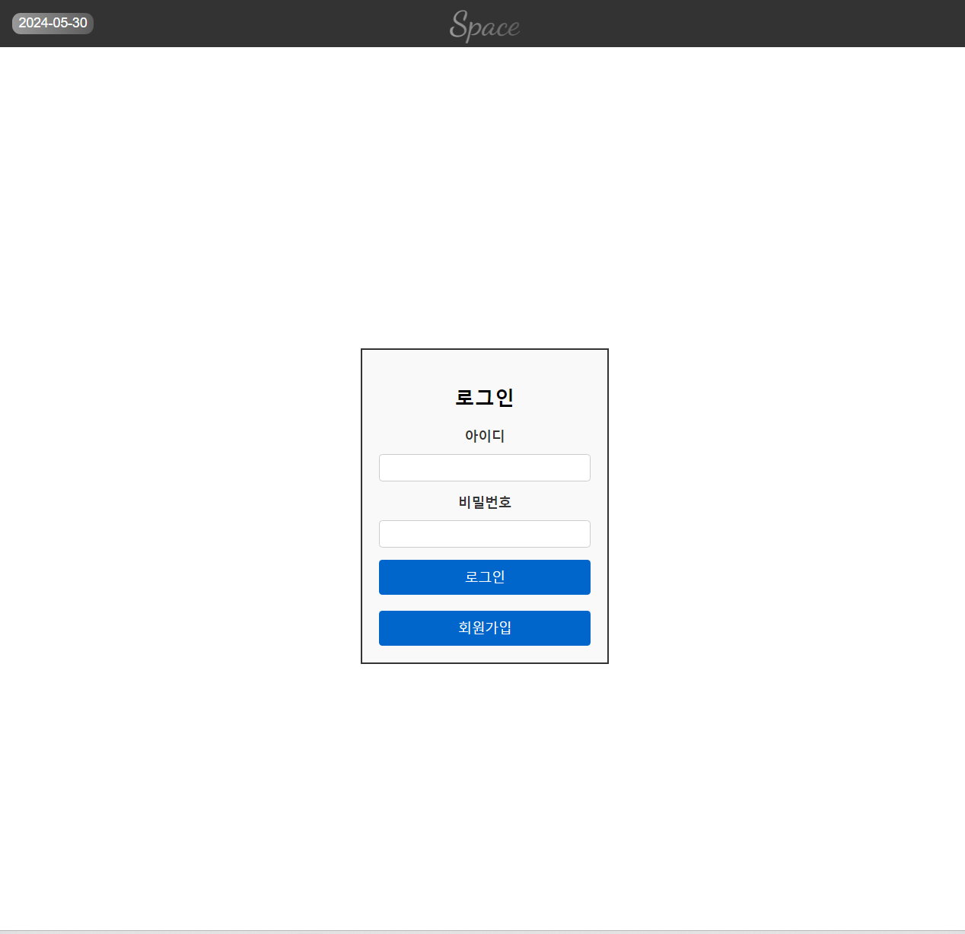

# 회원가입

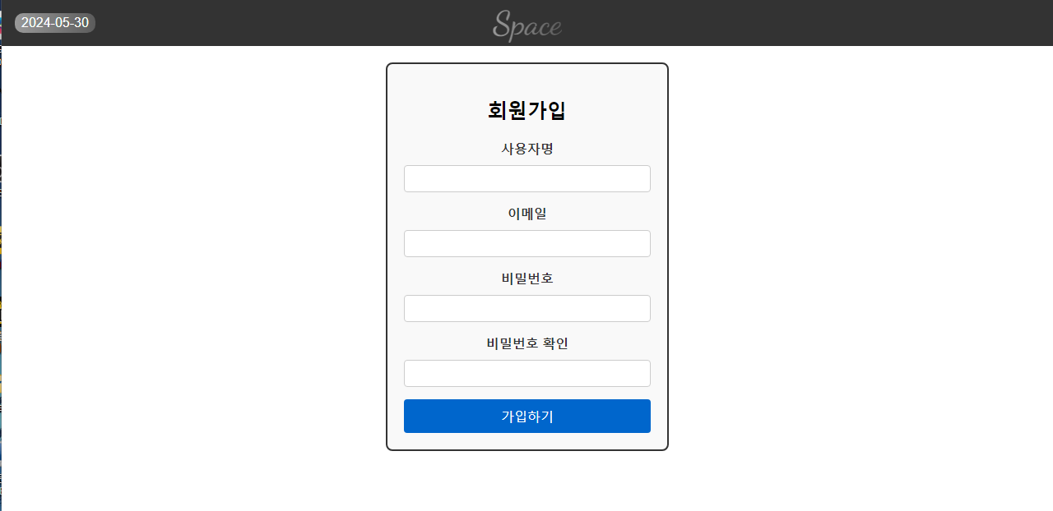

# 설문조사

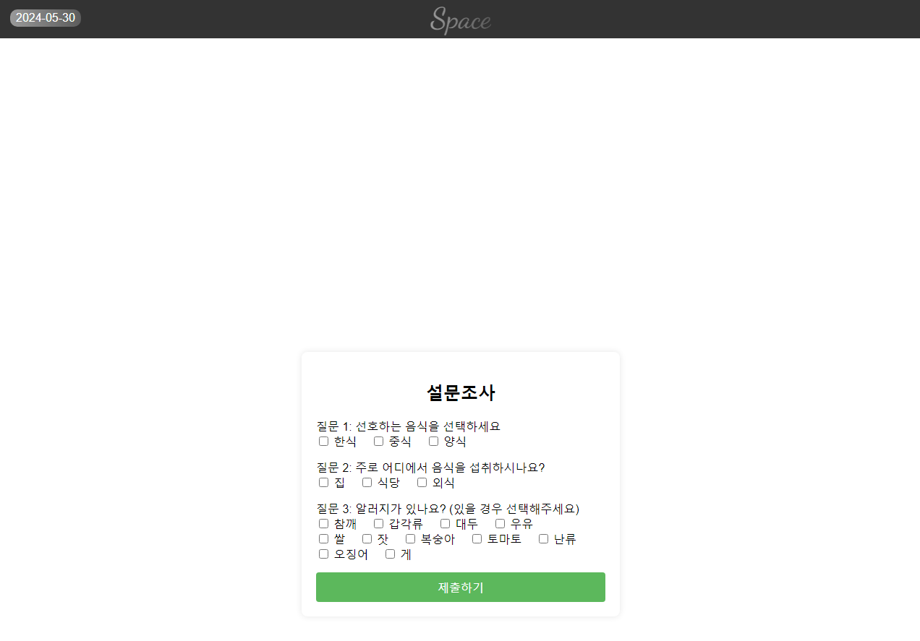

# 결론

## Configuration Identification

# 참고문헌

* 아마존 ai 모델 교육

# 일정

추가-송원석

**2.4 화면 설계**



